Evolving Pitching/Throwing Concepts & Techniques
Get back to the athleticism of the pitcher

There is a ongoing change in how coaches are teaching throwing/pitching today. The ideas and concepts in this article have been gathered from some of the outstanding coaches who have worked various ISG baseball clinics throughout Europe over the years – Brent Strom, Ron Wolforth, Derek Johnson, Craig Bjornson and Jerry Weinstein, just to name a few.

  - Primary shift – away from ‘positional’ teaching and toward teaching ‘movement’.
  - By definition ‘movement’ can never be a ‘position’ and a ‘position’ can never be a ‘movement’.
  - Throwing is an athletic movement...therefore we should focus on teaching movement.
  - The discovery: the magic isn’t in the dots…the magic is what happens between the dots.

Goals and Objectives: To get the pitcher to understand and develop through “guided discovery”:

1) balance and posture
2) lifting and moving
3) stride and momentum (using the middle part of the body)
4) opposite and equal
5) get it coiled and uncoiled correctly
6) separation and delayed shoulder rotation
7) movement which incorporates rotation and linear aspects
8) stability and finish

Some original assumptions that are no longer valid:

Pause at the top: destroys momentum and the athlete’s natural rhythm and the pause actually induced the very thing coaches wanted to avoid…rushing

Pull the glove to the hip: this encourages momentum out of sequence and inhibits hand speed because it works against the natural “kinetic whip” action of working around a fixed point - around a firm front side glove and isometric positioned front hip joint at foot strike

Keep the head still throughout release: the center of mass (Core) is what is important to control. That the center changes as the body moves through various planes creating concentric - eccentric movements. There is body movement, elasticity and flexibility accumulating forces to throw.

Slow the body down for control: most pitchers deliveries are too deliberate. Move the
pitcher in the direction of accelerated activity but the tempo eventually becomes individual to each player. The pitcher should dance; they must establish pre moves which tie segments together to allow them to gain momentum at maximum velocity prior to moving to the next segment.

Stay Back: one must overcome inertia. Stalling out over the rubber with limited momentum Build up hurts stride length and rotational capabilities. As I lift – I am on my way. Moving out, off the rubber correctly allows the momentum to build, and the proper rotation of the lower half with momentum buildup “yanks” the upper torso into a squared up position at release.

Counter Rotation: Excessively turning away from the intended target with the torso does not initiate tension in the back side hip. Correctly pinching the front side hip back into a resisting
back side hip promotes tensions which we must attempt to hold onto until late release. Load up on the inside of the pivot leg and release that energy at the right time.

Post Foot Positioning: look at the old timer’s. They pre-set the post foot with the toe slightly forward to establish tension in the back side, to help with direction and limit counter rotation. Parallel Posting the pivot foot parallel to the rubber was a precursor to posting up, getting to a balance position and static balance. And, while the best never did it, the teach helped create a “load up today, unload tomorrow” type of movement, devoid of momentum

High Cock Position: a major teach, coaches placed pitchers in this position and along with
balancing on one leg proceeded to throw from here. Well intentioned teaches such as,
“thumb to the thigh, ball to the sky”, reach back, make a big circle behind you,” break
your hands early to get to a certain position, killed velocity and lift to the ball.
Developing proper arm action is the #1 thing to enhance throwing ability. How the
various points of movement are attained is more important than the positioning of the
points with regards to time and space.

Rushing: this is not a body movement problem but is a function of poor synchronization of the arms. Staying connected utilizing the pelvis and back to control the extremities will help with timing.

Connection and Disconnection are important factors in effective throwing mechanics – Next Month we will discuss those elements with photos.
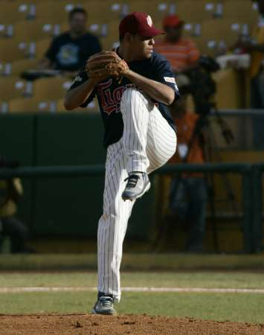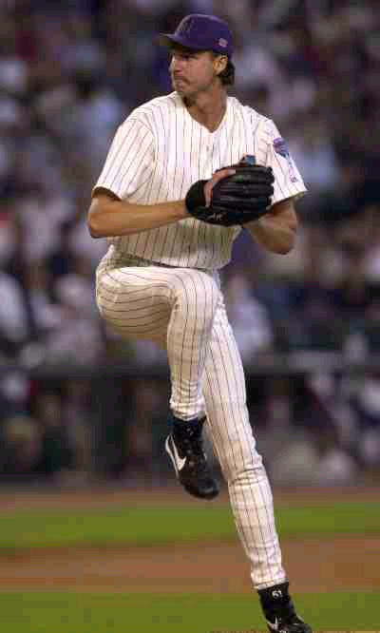
Correct Loading of Energy – No over rotation As I lift, I am on my Way – Hips Lead
Late Hip Rotation
Later Shoulder Rotation 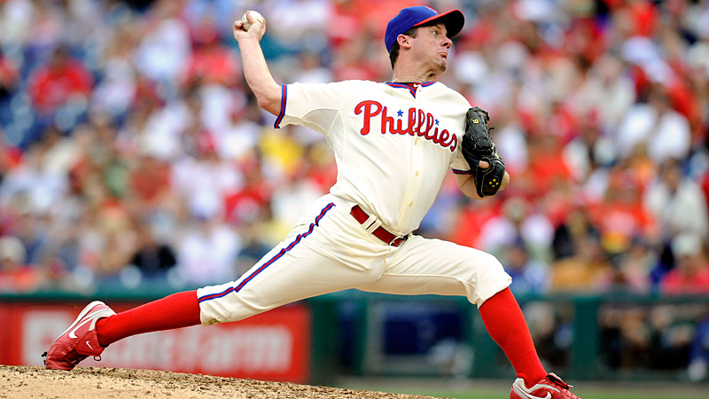 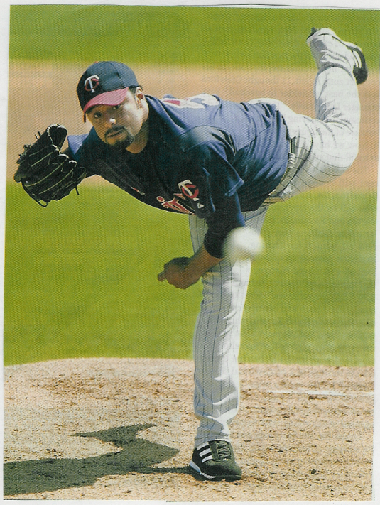Full Follow through around a Firm Front Side

